Objective Questions
- What is the total no. Of tables present in the data?
Ans. The dataset contains 1 table named “tbl_clean”.

- What is the total no. Of attributes present in the data?
Ans. The dataset contains 30 attributes. These attributes include identifiers (ids), categorical fields (agent, guru, product), numeric fields (call duration, sale amount, csat), and time-based fields (date, time).

- The data consists of some inconsistent and missing values so ensure that the data used for further analysis is cleaned?
Ans.
Data cleaning steps performed:
- Removed blank rows and duplicates (data → remove duplicates)
- Replaced missing call duration and rating with average values
- Filled missing categorical fields (like consultationtype) with “unknown”
- Removed outliers and formatted date/time fields properly.

- What is the change in daily call volume day by day and also find the average daily call volume?
Ans.
Guideline:- Analyze daily call volume trends using line charts and calculate average calls per day to understand fluctuations and plan staffing.

Visual Representation: -
(Column Chart showing daily calls over time + Waterfall Chart showing change in daily call volume)
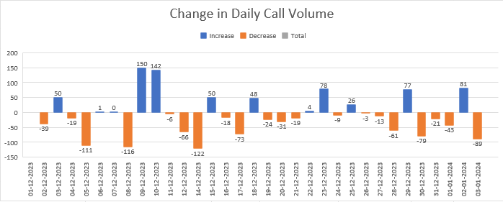
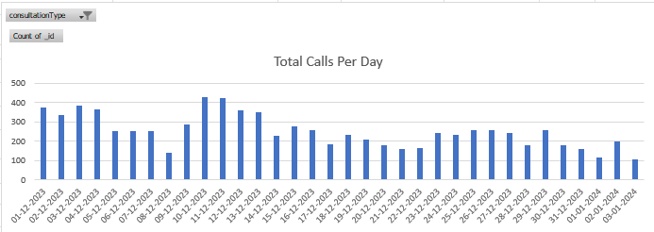

Observation:
- The call volume changes significantly from day to day.
- Big drops occurred (-122 on 14-Dec, -116 on 8-Dec), while spikes happened (+150 on 9-Dec, +142 on 10-Dec).
- On average, the call center handles 250 calls/day.

Insight:-
Call demand is unstable, requiring flexible staffing. More agents should be scheduled on peak days, with adjustments on low-demand days.

- Which months experienced the highest and lowest call volumes?
Ans.

Approach: -

- Ensure date column is correct
- Make sure the date column (Created_At) contains valid Excel dates. And derive the month column from it.

- Insert a PivotTable
- Insert -> Pivot table -> Current Table range -> check Add this data to the Data Model -> Click Enter.

- Build the Pivot
- Rows: Drag the Month (CreatedAt) into Rows.
- Values: Drag CallID (or _id) to Values and ensure it shows Count of CallID.

- Filter to calls only
- Add ConsultationType to the Filters area and select Call only.

- Create a chart
- With the Pivot selected, Insert → Column Chart to show Call Volumes. And Show Data Labels in the chart options to make the numeric count visible.

Visual Representation: -
(Column Chart with Months vs. Total Calls)

Observation: -

From the monthly call volume analysis:
- Highest: December 2023 with 8,090 calls.
- Lowest: January 2024 with 418 calls.

Insight:-
December is a high-demand period requiring more resources, while January is a low-demand month, highlighting seasonal variation in customer demand.

- What is total operational cost for that month?
Ans. The total operational cost for
- December 2023: ₹73,925.84
- January 2024: ₹3,873.60
- Total for both months: ₹77,799.44.

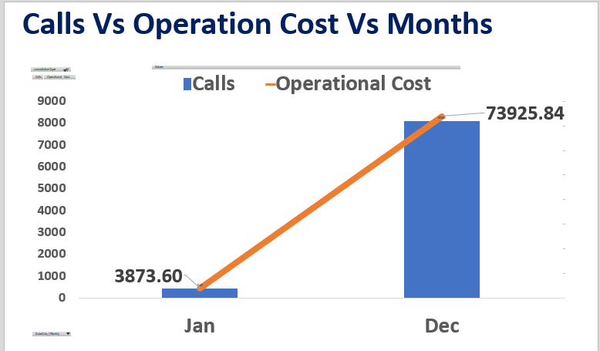

Insight:
Costs scale directly with call volume. High-volume months significantly drive operational expenses.

- What is the average number of calls handled per agent per day?
Ans.
Approach: -
- Find Total Calls: -

- We need the total number of calls made during the entire period.
Since the dataset contains both Call and Chat consultation types, first filter it for Call records only.

- So, we use the Formula: - =COUNTIFS(Tbl_Clean[consultationType],"Call")
- Find Distinct Agents: -

- We must find out how many unique astrologers (agents) handled calls during this period. For that we used this formula.

- =COUNTA(UNIQUE(Tbl_Clean[guruname_n]))

- Where: -

- UNIQUE () extracts each astrologer’s name once (removes duplicates).

- COUNTA () then counts how many unique astrologers (agents) there are.
This gives the Distinct Agent Count

- Find Distinct Active Days: -

- Next, we calculate how many unique days the call center operated - that is, how many different dates appear in the dataset.

- So, we use the Formula: - =COUNTA(UNIQUE(Tbl_Clean[DateOnly]))

- Where: -

- DateOnly is the column you derived from the original timestamp (CreatedAt) using the formula =INT([@CreatedAt]).

- This removes time and gives only the date (e.g., “2024-01-15”).

- The UNIQUE () function lists each distinct date once, and COUNTA () counts them.
That gives the Distinct Active Days

- Calculate the Average Calls per Agent per Day

- Now that we have: Total Calls = 8508 and Distinct Agents = 148

- Distinct Active Days = 34

- We use the formula: = Total Calls / (Distinct Agents * Distinct Active Days)

- And Hence We Get Our Answer 1.69 which is rounded up to 2 Calls
- Average number of calls handled are 2 calls per day per agent
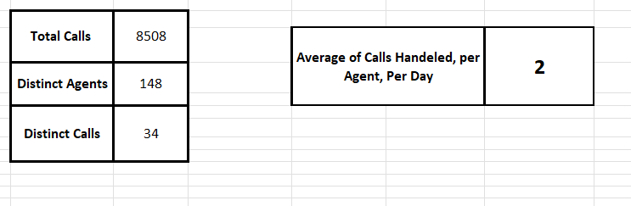

Insight:
- This means each astrologer handles roughly 2 calls daily, suggesting the workload is moderate and evenly distributed.
- It also implies that the center has sufficient staff to manage daily call volumes efficiently.
- But there is Low utilization which suggests overstaffing or inefficiencies in workload allocation.

- How many repeat callers are there, and what percentage of total calls do they represent?
Ans.
Approach: -
- Created a Pivot Table from TBl_clean table.
- Where Pivot table is filtered by consultation type: - calls
- In Rows we added uid, and Count of uid as Values.
- For each unique uid:
  - First call - initial contact.
  - Subsequent calls - repeat calls.
- Repeat Calls Column was derived by ignoring the first call that means count of (uid’s - 1).
- To get the Repeat Callers we used this formula: - =SUM (D117:D3745), where we did sum of entire Repeat Calls Column.
- To get total calls we used this formula: - =COUNTIFS(Tbl_Clean[consultationType],"Call")
- As you can see the repeat callers are 4879 and total calls are 8508
- So, by dividing repeat callers by total calls, and converting to percentage, and by rounding off we get 57% of repeat callers.

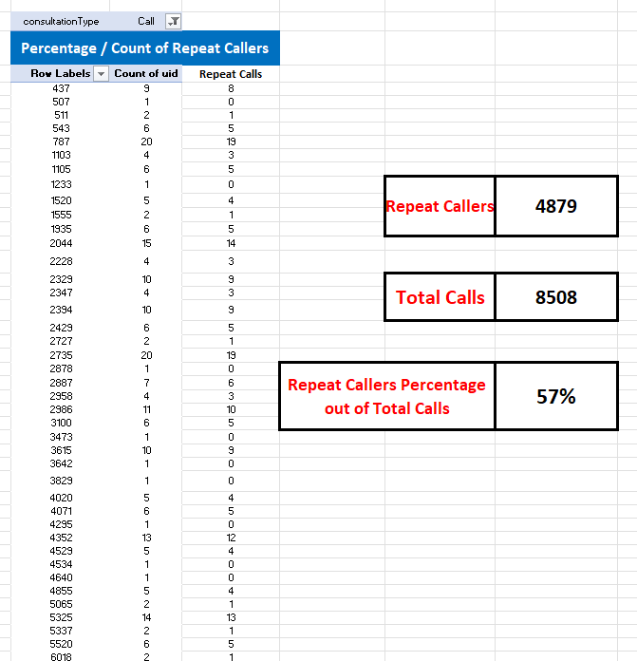

Insight:
Over half the total of calls are repeat calls, which clearly states the user calls again after the first call, due to same or related issues, so educating the agents to try solving the issues rather than dragging it for other calls, as it can lead to loss of reputation of the company.
- What are the total sales generated by the call center for each product category?
Ans.
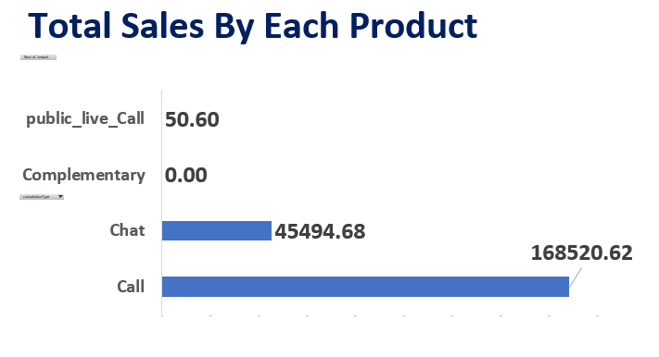
- Calls: ~79% of sales
- Chats: ~21% of sales.
- Public live call & complementary: 0% of sales
Insight:
Revenue is heavily dependent on call consultations, requiring diversification to reduce risk.

- How many calls were made for each user id and guru id?
Ans.
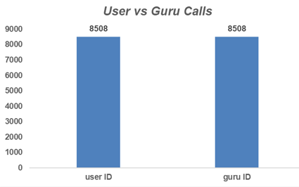
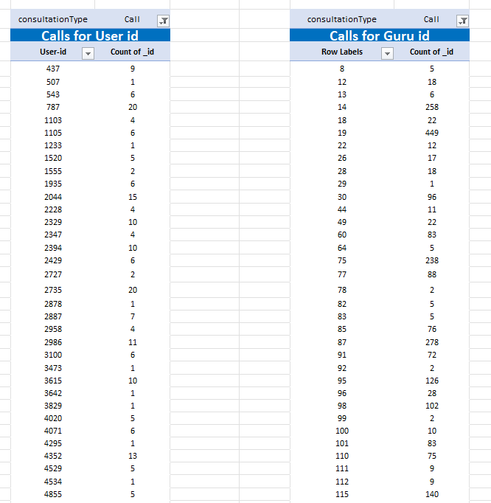

Observation:
- Total: 8,508 calls were made for both User IDs and Guru IDs.

Insight:
- This segmentation supports retention strategies and workload balancing across the users and gurus.

- What is the correlation between call duration and customer satisfaction?
Ans.
Approach:-
- Handled Missing Values:
  - In the userOnCallDuration column, blank cells were replaced with "NA" to represent Not Applicable for Chat cases.
  - This ensures that every record has a value, while keeping non-call rows clearly distinguishable, and "NA" entries are automatically ignored by Excel’s correlation function, so they do not affect the result.

- Applied the Correlation Formula:
  - A simple correlation formula was used to measure the relationship between call duration and customer rating:
  - =CORREL(Tbl_Clean[userOnCallDuration], Tbl_Clean[rating])

- Observed the Result:
  - The output of the formula was -0.0002.
  - This value is very close to 0, which means there is no linear relationship between call duration and customer satisfaction ratings.

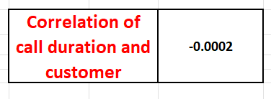

Insights:
- Customers rating is not dependent on call duration. Short or long calls lead to similar satisfaction outcomes.

- Astro-Sage should emphasize service quality, responsiveness, and communication clarity rather than extending call durations.
- Which guru has the highest and lowest customer satisfaction scores?
Ans.
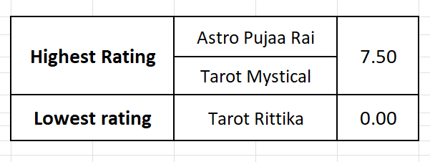

- What is average customer satisfaction score by month?
Ans.
- December: 2.9
- January: 2.7
Insight:
Scores remain consistently low (<3) - urgent need to improve service quality.

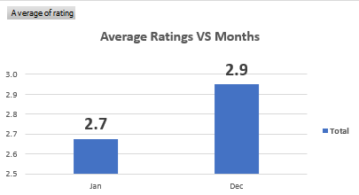

- How many categorical columns are there in the data?
Ans. Categorical columns means non numeric columns, which are 15
Columns like: -
Chatstatus, consultationtype, website, refundstatus, iswhitelistuser, queue, freecall, freechat, callchannel, callivrtype, callstatus, astrologercallstatus, region, usercallstatus, rating.
Subjective Question:

  - Should the investment be used to hire more agents, improve training programs, or upgrade call center technology?

  - Should they Hire More Agents?
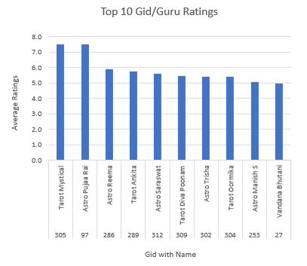
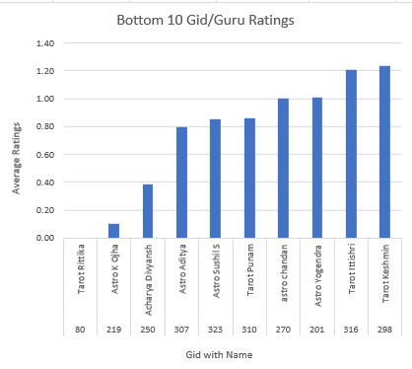

Insights:
- I created two pivot charts to compare Top 10 and Bottom 10 Gurus by Average Rating using the columns gid/guruname_n and rating.
- The Top 10 chart shows astrologers consistently achieving ratings between 7.5 and 5.5, while the Bottom 10 chart shows ratings mostly below 1.2.
- The variation in ratings between agents highlights inconsistency in service quality, rather than a lack of workforce.

Recommendation:
- Do Not Hire Immediately as the data does not indicate overburdened staff .Hiring new agents would increase operational costs without guaranteed improvement in customer satisfaction.
- Invest in agent training programs to improve issue resolution and communication skills. Introduce smart routing and queue management systems (CRM/IVR) to balance workload dynamically.
  - Should they Improve Training Program?

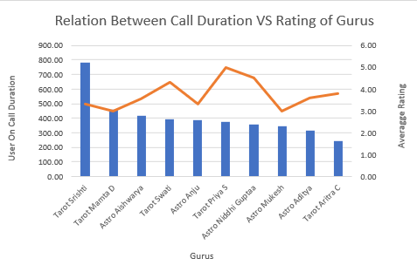

Insights:
  - To evaluate this, a combo chart was created comparing Average User Call Duration (blue bars) and Average Rating (Orange line) for the Top 10-performing Gurus based on call consultations.

  - Tarot Srishti has the highest average call duration (785) but only a moderate rating (3.3), which indicates that spending more time with a customer does not necessarily improve satisfaction.

  - Tarot Priya S and Astro Niddhi Guptaa maintain average durations (350-380) yet achieve very high ratings (4.5-5) which suggests that communication quality and issue resolution skills matter more than call length.

  - Lower-performing gurus like Astro Aditya and Aritra C show shorter durations and lower ratings, pointing to a lack of engagement or weaker communication skills.

Recommendation:
- Based on the analysis, the call center should definitely improve its training programs, focusing on:
- Train agents to resolve issues quickly without making calls unnecessarily long.
- Enhance the way agents interact with customers to build trust and satisfaction.
- Provide refresher sessions on astrology services and customer handling techniques to reduce uncertainty during calls.
- Regularly review ratings and duration patterns to personalize coaching for each guru.
  - Should they Upgrade Call Center Technology?

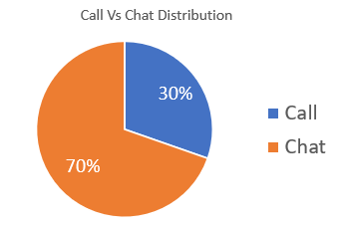

Insights:
- A Pie Chart was created comparing the distribution of Calls and Chats from the dataset. The chart reveals that Chats make up nearly 70% of total customer interactions, while Calls account for only about 30%.

- Chat consultations dominate (70%) - this means customers are increasingly choosing faster, more convenient digital interactions.

- Calls (30%), while still important, show that voice-based support is less frequently used, possibly due to longer waiting times or less accessibility.

- High chat volume also suggests that existing chat systems handle the majority of workload, putting stress on messaging infrastructure, chat routing, and response management systems.

Recommendation:
- Integrate an Omni-channel CRM: Centralize customer data across both calls and chats so agents can access interaction history and improve consistency.

- Adopt AI-powered Chatbots: Use automation for initial chat handling to answer FAQs, allowing human agents to focus on complex cases.

- Upgrade Chat Infrastructure: Implement better chat-routing, real-time dashboards, and response-time monitoring tools.

- Enhance IVR and Call-back Systems: Even though calls are fewer, smarter routing and self-service options can reduce customer wait times.

- Performance Analytics Tools: Implement real-time monitoring dashboards to track chat-to-resolution times, agent load, and customer sentiment.
  - What are the potential risks of each investment option (hiring, training, technology upgrades), and how can they be mitigated?
Ans:-

A. Hiring
- Risks: Overstaffing (waste of budget), temporary demand reduction, increased fixed payroll.
- Mitigation: Use WFM forecasting (hire contractors/part-time, trial hires). Hire only for measured peak hours
- Excel tools: Pivot Hour × Date heatmap; =CEILING () staffing model; data table for scenario analysis.

B. Training
- Risks: Short-term drop in throughput while agent’s train; training may not change behaviour without accountability.
- Mitigation: Stagger training, measure outcomes (before/after CSAT), combine with QA and coaching.
- Excel tools: Before/after pivot charts (Avg Rating by Guru pre/post training), paired t-test (or simple diff).

C. Technology
- Risks: Implementation complexity, vendor lock-in, integration delays.
- Mitigation: Pilot small, use measurable KPI’s (AHT, abandoned rate, CSAT) during pilot; vendor SLA review.

- Excel tools: ROI model (investment vs expected % AHT reduction -> revenue impact). Use Data Table or Scenario Manager.

  - How does astro-sage's call center performance compare to Astro guru’s average call volume, customer satisfaction, and agent performance? Will you use any aggregation function or a visualization here to solve the problem?
Ans.

For comparison of Astro-sage and Astroguru we don’t have any dataset of astroguru . Hypothetically if it was available we can easily perform the analysis by

- Harmonize columns (Date, callsid, consultationtype, Rating, AHT, agentid).

- Compute normalized kpis:
  - Avg calls / day, Avg CSAT, Avg AHT, Calls per agent per day.

- Visualize:
  - Clustered bar chart comparing each KPI across companies.
  - Radar chart for multi-dimensional comparison (volume, CSAT, AHT, repeat-rate).

- Use statistical summary: AVERAGE, STDEV.P, MEDIAN, and PERCENTILE.

Excel functions/visualizations: pivottable (side-by-side), Clustered Bar, Radar Chart, AVERAGEIFS.

Interpretation approach: Use normalized metrics per agent or per 1,000 customers (so size differences don’t bias view).

  - How can the call center improve its handling of peak call periods to ensure high customer satisfaction? Mention the functionality you will use for giving the suggestions, will it be any aggregated function or a visualization?

Ans: -
Here we can clearly see from the graph where vertical axis represents the total calls and horizontal axis represents the peak hours.

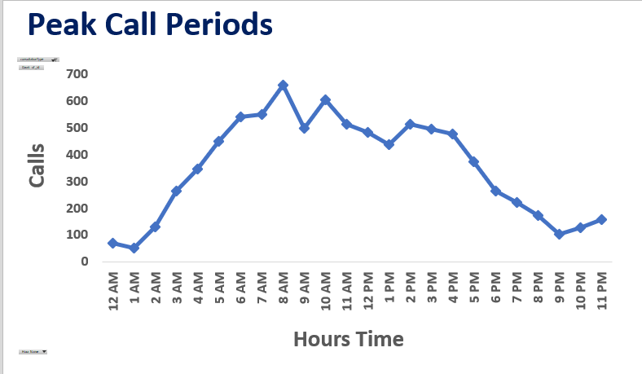

What the data shows: Peak hour is around 08:00, with 600+ Calls in that hour; other peaks around 10:00 and 11:00. With an average duration of 116.
Actions (operational + tech):
- Staff scheduling: Use WFM to add 1-2 extra agents in the 07:30-10:30 block (based on occupancy calculation).
  - Simple staffing formula:
$$\text{Agent-hours required}=\frac{\text{Calls/hour}×\text{AHT (seconds)}}{3600}$$
Then divide by target occupancy (e.g., 0.85) and round up.
- Callback & Virtual Queue: Offer callback at peak to reduce abandoned calls and improve CSAT.
- IVR & Skill-based routing: Direct high-value or repeat callers to senior agents.
- Chatbot triage: Offload simple FAQs to chatbots to lower call volume.
- Real-time dashboards & thresholds: Set alerts in Excel when queue length exceeds threshold.

  - Based on historical data, what strategic initiatives should be prioritized to improve efficiency and customer satisfaction?

Ans: -

Analysis Reference from Dashboard

To determine improvement areas, three key visuals were analysed:
- Peak Call Periods (Line Chart) - shows when call traffic is highest.
- Website-Wise Average Rating (Pie Chart) - represents customer satisfaction levels by platform.
- Percentage of Call Status (Pie Chart) - indicates operational success and failure rates.

Insights from Data:

- Peak Call Periods:

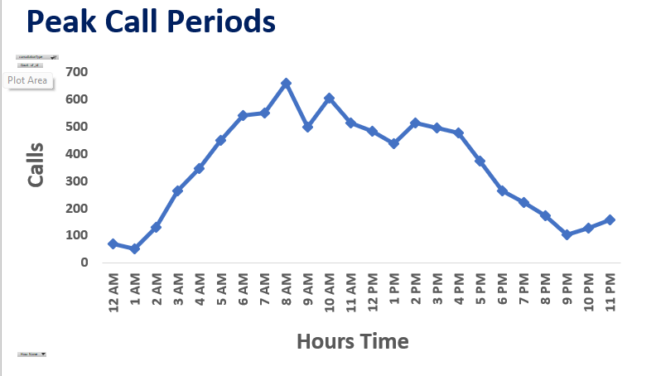

  - The line chart clearly shows heavy call volumes between 5 AM and 4 PM, peaking around 7-10 AM.
  - This indicates a potential resource bottleneck during morning hours where customer wait times and dropped calls could be higher.
  - Calls drastically decline after 4 PM, suggesting under-utilization of agents during later hours.

- Website-Wise Ratings:

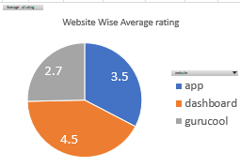

  - Ratings vary across platforms: Dashboard (4.5) > App (3.5) > Gurucool (2.7).

  - The dashboard performs best in user satisfaction, while Gurucool requires major improvement, possibly due to interface issues or slower response times.

  - This also shows that customer satisfaction is not consistent across platforms, hinting at a lack of unified quality control.

- Call Status Distribution:

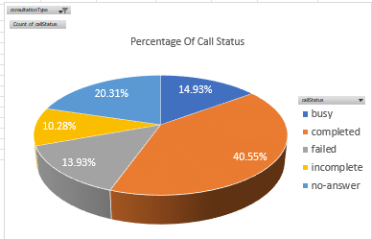

  - Only 40.55% of calls are successfully completed, while the rest fall into categories like busy (14.93%), failed (13.93%), no-answer (20.31%), and incomplete (10.28%).

  - High failure and no-answer percentages directly reflect inefficiency in call routing, scheduling, or agent responsiveness.
Strategic Initiatives to Improve Efficiency & Customer Satisfaction:

  - Workforce Optimization (Efficiency Focus):

- Implement dynamic scheduling: Assign more agents during 4-12 AM to match peak demand, and reduce idle agents in late evenings.
- Use real-time workforce management (WFM) tools to balance loads and minimize call drops.

  - Technology Upgrade:

- Introduce intelligent call routing and IVR systems to manage high-volume hours effectively.
- Deploy callback options during busy hours to prevent failed or missed calls.
- Enhance the Gurucool platform with faster response integration and performance monitoring.

  - Agent Performance and Training:

- Use average rating data per guru to identify agents needing improvement.
- Conduct focused training on customer empathy, communication, and first-call resolution.
- Regularly monitor average call duration and satisfaction metrics to identify burnout or inefficiencies.

  - Customer Experience Improvement:

- Standardize service quality across all platforms - app, dashboard, and Gurucool.
- Conduct post-call surveys to track real-time customer feedback.
- Introduce chatbots or AI-assist tools for basic queries to reduce pressure on call lines.

  - What can be the key factors contributing to high customer satisfaction scores, and how can these be leveraged to improve overall performance? What is the basis for the suggestions? And mention how you decided if the satisfaction score affects the ratings.

Ans.
Analysis Basis:
To determine the factors that contribute most to customer satisfaction, data analysis was conducted using:
- Customer Ratings (dependent variable)
- Call Duration, Consultation Type, and Website Source (independent variables)
- Statistical relationship measured using Excel’s CORREL() function.
Formula used:
=CORREL(Clean_data!AC2:AC28028, Clean_data!AE2:AE28028)
→ Where AC = User On Call Duration and AE = Ratings
Additionally, Website-wise ratings and Consultation Type (Call vs Chat) were analysed through pivot tables and charts to visualize satisfaction patterns.

Insights from Data Analysis:

- Correlation Between Call Duration and Rating:
  - The calculated correlation coefficient was approximately +0.59, indicating a moderate positive correlation.
  - This means longer, well-handled calls tend to produce higher satisfaction ratings - likely because customers feel more understood and their queries are resolved effectively.
  - However, excessively long durations could also signal inefficiency; hence, maintaining an optimal duration range is key.

- Website / Platform Influence on Satisfaction:
  - Ratings vary significantly across platforms:
    - Dashboard: 4.5 (highest satisfaction)
    - App: 3.5
    - Gurucool: 2.7 (lowest satisfaction)
  - This suggests that interface quality, ease of use, and response times strongly influence customer experience.
  - The Dashboard provides smoother interactions and likely faster response handling, while Gurucool may face technical or design issues that lower satisfaction.

- Consultation Type Impact:
  - Call interactions generally received higher average ratings of (3.5) compared to Chat interactions (2.7).
  - Voice calls allow for empathy and real-time problem solving, while chats may lack personal engagement.
  - This shows that direct communication enhances satisfaction.

Recommendations to Leverage These Insights:

- Enhance Training Based on Duration Analysis:
  - Train agents to maintain optimal call durations - long enough for resolution but short enough to remain efficient.
  - Focus on active listening and first-call resolution techniques.

- Upgrade Underperforming Platforms (Gurucool):
  - Improve UI responsiveness, reduce lag times, and integrate CRM tools for faster service.
  - Ensure consistent experience across all platforms.

- Promote High-Rated Consultation Modes:
  - Encourage customers toward call-based consultations for complex issues.
  - Integrate smart chatbots to improve satisfaction in chat channels.

- Monitor Performance Continuously:
  - Track average call duration, agent ratings, and satisfaction trends monthly using dashboards.
  - Use correlation insights to identify where performance improvements directly impact customer satisfaction.

  - How should the call center balance the workload among agents to ensure optimal performance and avoid burnout? Mention your approach and spreadsheet function for the answer.

Ans: -

To ensure optimal performance and avoid burnout, the call center should focus on equal workload distribution among agents based on the average number of calls handled per agent per day.
From the analysis, it is observed that some agents such as Dr. Shalini handle significantly more calls than the average baseline, while others manage much fewer. This uneven distribution can lead to agent fatigue, reduced quality of service, and inefficient resource utilization.

Approach:
- Calculate the Average Calls for top 10 Agents
  - The Average Calls are 278
  - Using this formula (=AVERAGE (range_of_calls))
This gives the baseline workload for comparison.

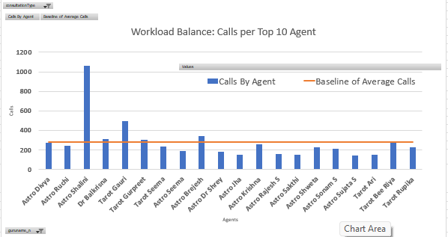
- Compare Individual Agent Workload Against the Average
  - To find the workload deviation for each agent:
  - =Calls_By_Agent - Average_Calls
    - Positive value: Agent is overburdened (above baseline).
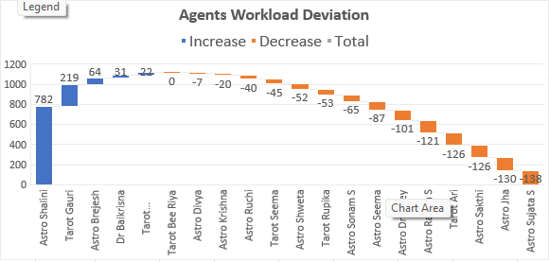
    - Negative value: Agent is underutilized (below baseline).

- Redistribute Workload:
  - Assign excess calls from overburdened agents to underutilized ones.
  - Adjust shift timings or incoming call routing based on these findings.

- Now Based on this data re-educate the Overburdened Agents to maintain the workload Balance, to avoid burnout and Ensure Optimum Performance.

- And Also Educate the under performing Agents To at least reach the base line to maintain good performance, and incentives can be a motivation to achieve it.

  - What new technologies or tools could be implemented to enhance call center operations and customer service?
Ans

- Machine Learning (ML) algorithms can analyse past call patterns to predict peak times and optimize scheduling.

- The call center can adopt ai-powered call routing to automatically direct calls to the most suitable agents based on skills, language, and performance.

- Predictive analytics can be used with Excel’s FORECAST.LINEAR() function to forecast daily or monthly call volumes.

- Implementing a Customer Relationship Management (CRM) system such as Salesforce or Zoho CRM can help store and track customer data and improve personalized service.

- Chatbots and voice assistants can handle repetitive customer queries, reduce agent workload and improve response time.

- A real-time analytics dashboard can be built using Excel’s Power Query, Power Pivot, and Power BI to visualize metrics like call volume, satisfaction scores, and agent performance.

- Cloud-based communication platforms like Twilio, Amazon Connect, or Genesys Cloud can manage calls, messages, and chats efficiently from any location.

- Automation through Excel functions like VLOOKUP () and IF () can simulate smart call routing by matching customer query types with agent specialization.

- Pivot Tables can summarize call data to identify workload imbalances and performance trends.

- Adopting these technologies will enhance efficiency, improve customer satisfaction, and prevent agent burnout.

  - What metrics should be included in the final dashboard to comprehensively view call center performance and guide investment decisions?
Ans: -
To provide a complete and actionable view of Astro-Sage’s call center performance, the dashboard integrates a mix of operational, financial, and customer-centric metrics. Each metric has been carefully selected to align with the company’s strategic goals of optimizing efficiency, and improving customer satisfaction

The final dashboard includes the following key metrics and visual components:

- Key Performance Indicators

- Total Calls & Total Chats -
These metrics represent the overall communication volume handled by the call center. They give a direct understanding of workload distribution between call and chat operations, helping assess staffing and capacity requirements.

- Cost per Call -
This metric helps evaluate the financial efficiency of operations by comparing total operational expenses with total call volume. It guides investment decisions by identifying whether resources are being optimally used or if cost reduction strategies are needed.

- Average Daily Calls -
These measures the average inbound traffic per day, indicating the typical daily workload. It helps in forecasting staffing needs and planning shifts efficiently.

- Repeat Callers (%) -
This shows how many users are reaching out multiple times, reflecting customer retention and satisfaction levels. A higher repeat rate may indicate ongoing engagement or unresolved issues, requiring further analysis.
- Average Rating (Customer Satisfaction) -
These measures the overall quality of service delivered by astrologers. It is a key performance indicator for understanding user satisfaction, service consistency, and agent effectiveness.

- Performance Charts

- Calls vs Operational Cost (Trend by Month) -
A combination chart showing how call volume and cost change over time. This helps in identifying whether increasing calls correspond to increasing costs, or if productivity is improving.

- Percentage of Call Status -
A pie chart visualizing the distribution of call outcomes (Completed, Busy, Failed, Incomplete, No-Answer). This highlights operational bottlenecks and agent efficiency in converting incoming requests into successful consultations.

- Peak Call Periods (Hourly Trend) -
A line chart displaying call distribution by time of day. It helps in planning agent shifts and ensuring that more astrologers are available during high-demand hours.

- Total Sales by Each Product
A bar chart displaying revenue generated by each product type (Call, Chat, Public Live Call, etc.). It identifies top-performing services and supports investment decisions for product development and marketing.

- Website Distribution (App, Dashboard, Gurucool) -
This shows which platform users prefer for consultations. It informs marketing and technology investment decisions based on user behaviour trends.

- Workload vs Average Baseline (Top 10 Agents) -
This chart compares each astrologer’s call handling volume with the average workload (baseline of 278 calls). It identifies workload imbalance, helping prevent burnout and optimize staff scheduling.

- Rating by User Call Duration -
A horizontal bar chart that correlates average call duration with customer rating. It helps understand whether longer consultations lead to higher satisfaction or reduced efficiency.

- Top 10 Highest and Lowest Rated Gurus -
These visuals rank astrologers based on user feedback. They highlight the top performers for recognition and identify those needing further training or quality improvement.

  - How would you allocate a 1 crore rupee investment to optimize operational efficiency, enhance customer satisfaction, and boost profitability, and what analysis-based recommendations would you offer to support this? [you have to give bullet pointers to answer this question]

Ans:-
Based on the complete dashboard analysis of Astro-Sage’s call center performance, the ₹1 crore investment should be strategically allocated across key operational and customer-focused areas to maximize impact.

1. Agent Optimization and Training: -₹25 Lakhs
- Conduct skill-based training programs for astrologers to improve communication, accuracy, and consultation quality.
- Use insights from the Rating by Guru and Rating by Call Duration charts to identify underperforming astrologers for targeted coaching.
- Introduce performance-based incentives to boost motivation and productivity.

2. Technology and Infrastructure Upgrade: -₹20 Lakhs
- Invest in advanced call management systems (IVR, call routing, auto-callback features) to reduce failed or missed calls seen in the Call Status chart.
- Enhance server infrastructure and implement AI-based chatbots for handling basic customer queries, reducing workload on astrologers.
- Integrate real-time analytics tools to monitor call trends and service quality.

3. Hiring and Workforce Expansion: - ₹15 Lakhs
- Based on the Workload vs Baseline and Peak Call Periods charts, hire additional astrologers for high-demand hours.
- Maintain an on-demand resource pool to handle seasonal traffic spikes efficiently without increasing fixed costs.

4. Marketing and Customer Retention Initiatives: -₹15 Lakhs
- Use data from Repeat Callers and Website Distribution charts to design targeted loyalty programs and personalized offers for frequent users.
- Launch digital campaigns promoting top-performing services (identified in Total Sales by Product).
- Collaborate with influencers and social media campaigns to expand reach and improve brand visibility.

5. Product Enhancement and Diversification: -₹10 Lakhs
- Enhance high-revenue services like Call Consultations while refining low-performing products such as Chat and Public Live Calls.
- Introduce combo offers or subscription plans to increase transaction frequency and user retention.
- Use dashboard insights to reprice underperforming products for better profit margins.

6. Quality and Customer Experience Improvement: -₹10 Lakhs
- Deploy post-call feedback systems to monitor customer satisfaction in real time.
- Implement AI-based sentiment analysis on chat/call transcripts to identify service gaps.
- Regularly review customer complaints and ensure prompt redressal to strengthen trust.

7. Monitoring, Reporting & Continuous Improvement: -₹5 Lakhs
- Set up a centralized analytics dashboard for real-time performance tracking using Power BI/Excel automation.
- Schedule monthly KPI reviews based on metrics such as Cost per Call, Average Rating, and Operational Cost vs Calls.
- Use predictive analytics to forecast future workloads and resource needs.

- Expected Outcomes
- Operational Efficiency: 20-25% reduction in idle time and call drop rates.
- Customer Satisfaction: Expected improvement of 15-20% in average rating and repeat engagement.
- Profitability: Cost per call reduced, revenue per call increased through optimized workforce and product focus.

